01.04.2024

**Step by Step Notes for VPN Creation in AWS Cloud**

VPN LAB  
31.03.2024

1 - Jump Server

2 - VPN

- Physical VPN

- Virtual VPN

- Software VPN

VPN Lab

- Setup a VPN

- Connect your Private Subnet EC2 directly from your laptop using Private IP.

Launch a OpenVPN EC2

Launch a EC2

Go to Browse more AMI >>> Marketplace >>> VPN >>>> OpenVPN >>> Select

Caution >>> Downgrade your Instance type to >>>>> t2.micro

Choose your VPC >>> Public Subnet >>> Enable Public IP >>>> Look at those SG rules

Launch Instance

Username for this OpenVPN >>>> openvpnas

Once you login

Type "YES" to accept EULA

Enter

Will this be the primary Access Server node?

Type "YES"

Enter

Please specify the network interface and IP address to be

used by the Admin Web UI:

Type "2"

Enter

What public/private type/algorithms do you want to use for the OpenVPN CA?

Simply press "ENTER"

What public/private type/algorithms do you want to use for the self-signed web certificate?

Simply press "ENTER"

Please specify the port number for the Admin Web UI.

Simply press "ENTER"

Please specify the TCP port number for the OpenVPN Daemon

Simply press "ENTER"

Should client traffic be routed by default through the VPN?

Simply press "ENTER"

Should client DNS traffic be routed by default through the VPN?

Simply press "ENTER"

Should private subnets be accessible to clients by default?

Simply press "ENTER"

Do you wish to login to the Admin UI as "openvpn"? <<<<<<<<<< WEB UI User name >>>>>>>>>>>>>>>>>>>>

Simply press "ENTER"

Type a password for the 'openvpn' account (if left blank, a random password will be generated):

Type your PWD and press enter, as you know you can see that, type and press enter

Please specify your Activation key (or leave blank to specify later):

Simply press "ENTER"

Admin UI: https://3.127.222.59:943/admin

Client UI: https://3.127.222.59:943/

Try to login to the Admin UI >>> Advanced >>> proceed

Username - openvpn

PWD >>> yourpwd which you set above in the OS

Agree

Login

Status >> Status Overview >>> explore everything

HOw to set up a software VPN

whats next ???

Test your VPN by connecting to your Private subnet EC2 using private IP

Now, open your client UI, Try to download and install the tool in your local machine and get that connected

NOw launch a new Linux EC2 in private Subnet and try to connect that using private IP

if it is working, your VPN is successful.

------------------------------------------------------------------------------------------------------------------------------------------

Now Login to the AWS Console and go to EC2 Service to create the VPN

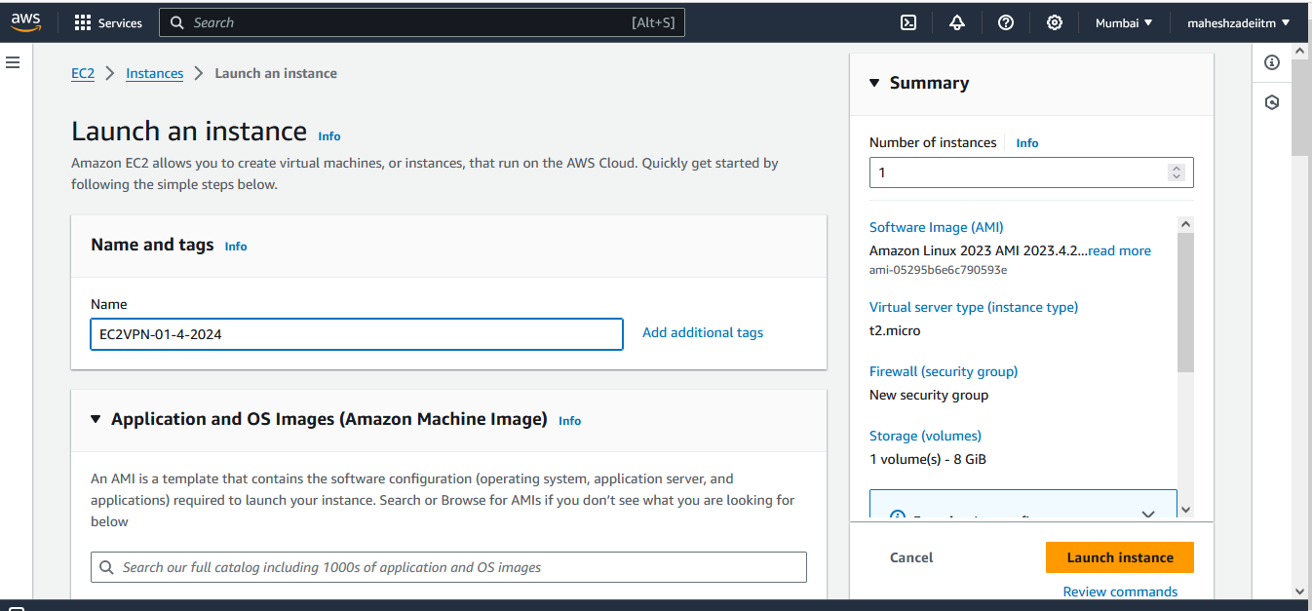

Click on Browse more AMI

Select AWS Marketplace AMI

Type VPN in search bar

Select OPEN VPN access server

Click on subscribe on instance Launch.

Change the instance type from t2 small to t2.micro ( free tier eligible )

Select the keypair for Mumbai region

Edit Network setting choose you custom VPC and public subnet

Select default security group

Instance Launched

Copy public IP

Paste in Mobaxterm

Type Public IP from ECVPN

Type User name as = openvpnas

And select the Private key for mumbai region

It will start VPN Installation automatically once you connect with openvpnas password .

Username for this OpenVPN >>>> openvpnas

Once you login

Type "YES" to accept EULA

Enter

Will this be the primary Access Server node?

Type "YES"

Enter

Please specify the network interface and IP address to be

used by the Admin Web UI:

Type "2"

Enter

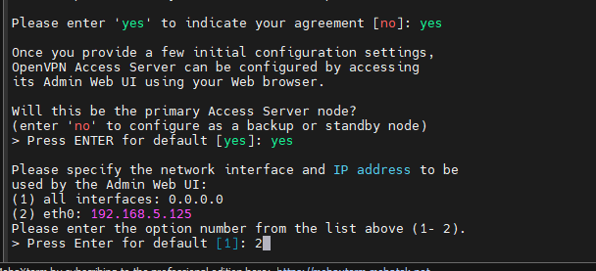

What public/private type/algorithms do you want to use for the OpenVPN CA?

Simply press "ENTER"

What public/private type/algorithms do you want to use for the self-signed web certificate?

Simply press "ENTER"

Please specify the port number for the Admin Web UI.

Simply press "ENTER"

Please specify the TCP port number for the OpenVPN Daemon

Simply press "ENTER"

Should client traffic be routed by default through the VPN?

Simply press "ENTER"

Should client DNS traffic be routed by default through the VPN?

Simply press "ENTER"

Should private subnets be accessible to clients by default?

Simply press "ENTER"

Do you wish to login to the Admin UI as "openvpn"?

Do you wish to login to the Admin UI as "openvpn"? <<<<<<<<<< WEB UI User name >>>>>>>>>>>>>>>>>>>>

Simply press "ENTER"

Type a password for the 'openvpn' account ( India@123)

(if left blank, a random password will be generated):

Type your PWD and press enter, as you know you can see that, type and press enter

Please specify your Activation key (or leave blank to specify later):

Simply press "ENTER"

Initial Configuration Complete!

Pls copy the web url for admin and client.

You can now continue configuring OpenVPN Access Server by

directing your Web browser to this URL:

https://43.205.239.96:943/admin

During normal operation, OpenVPN AS can be accessed via these URLs:

Admin UI: https://43.205.239.96:943/admin

Client UI: https://43.205.239.96:943/

To login please use the "openvpn" account with the password you specified during the setup.

See the Release Notes for this release at:

https://openvpn.net/vpn-server-resources/release-notes/

openvpnas@ip-192-168-5-125:~$

Copied the Admin URL I Chrome Broweser

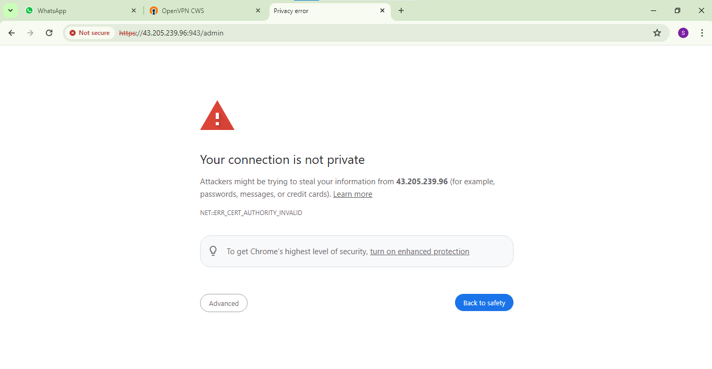

Click on Advanced

Type user name and password as

User name : Openvpn

Password : India@123

Click on agree

Go to status over view

2 VPN connections are allowed

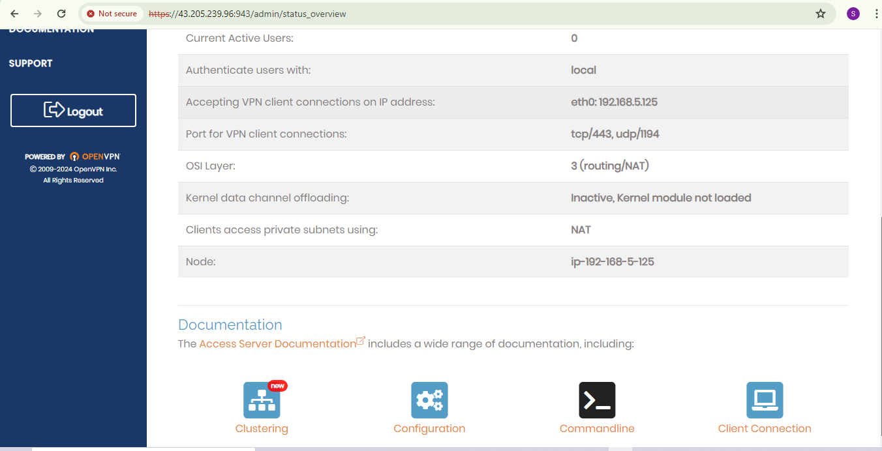

Now Copy the Client vpn url in incognito in chrome and configure

User name : Openvpn

Password : India@123

Download windows VPN Client from the icon windows

Click on more info

Click on run away

Click on Next

Click on Install

Click on agree

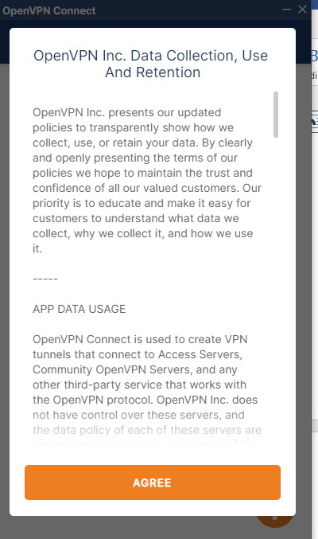

Type the password India@123

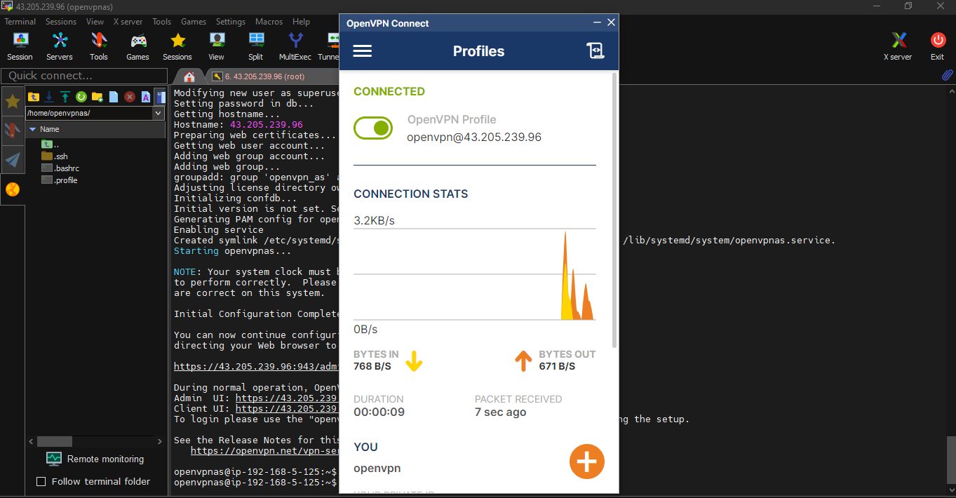

VPN Connected

Wehave setup a VPN

HOw to set up a software VPN is successfully done now .

whats next ???

Test your VPN by connecting to your Private subnet EC2 using private IP

Now, open your client URL, Try to download and install the tool in your local machine and get that connected

Now launch a new Linux EC2 in private Subnet and try to connect that using private IP

if it is working, your VPN is successful.

Edit Network Settings

Disable the public IP and selected private subnet .

Security group is default

Click on launch Instance

No Public IP assigned

Copy Private IP

Paste in Bobaxterm

Click on OK

Now successfully connected the EC2 Linux Instance by Client VPN in my Laptop .

if it is working, your VPN is successful.

Thanks

Pls check my Hands on done today taught us in yesterday class by Mahesh Babu Sir .

Pls check and updated .